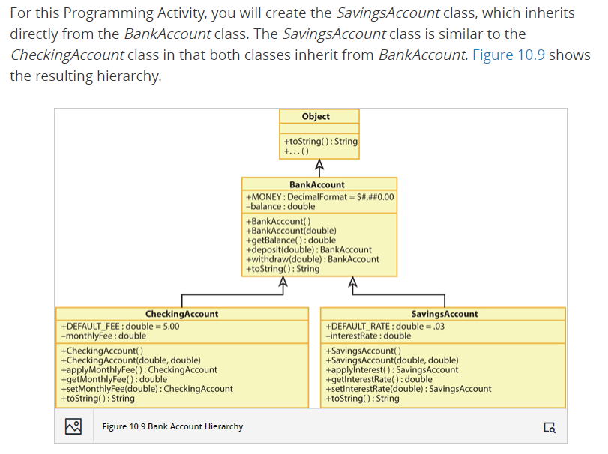

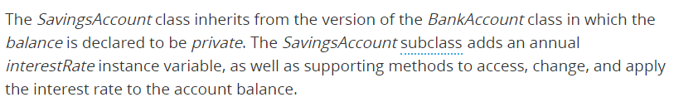

Instructions:

Copy the source files from the zip file to a folder on your computer. Load the *SavingsAccount.java* source file and search for five asterisks in a row (*****). This will position you to the six locations in the file where you will add code to complete the *SavingsAccount* class. When you completed the six tasks, load, compile, and use the client class to test your code by calling the *SavingAccount* methods. Submit only **the client class** and **SavingAccount class.**